Display the rankings of contingency tables using symmetric measures and asymmetric measures for the following data.

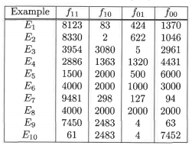

Table 1: Symmetric measures:

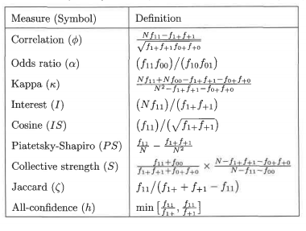

Table 2: ASymmetric measures:

